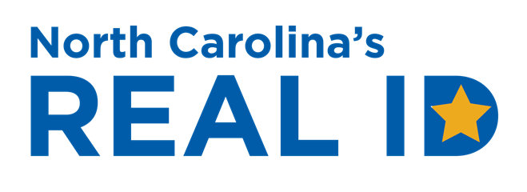
SOCIAL MEDIA SAMPLES
Copy/paste any of the below
messages to use in your networks.

LONG MESSAGES FOR FACEBOOK & INSTAGRAM

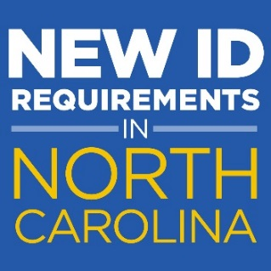

The #NCDMV now offers REAL ID, a single form of identification that meets new federal ID requirements to travel on commercial airlines and enter military bases and federal facilities. Get more information about #NCREALID, including the list of required documents, at NCREALID.gov.

Renew your #NorthCarolina license or identification card as a #REALID to use as a single form of identification to fly or visit military bases and federal facilities. Get the complete list of required documents before you renew at NCREALID.gov.

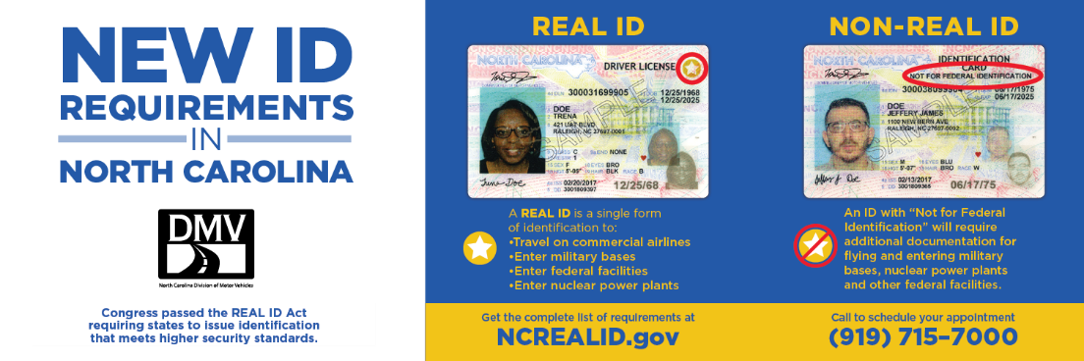

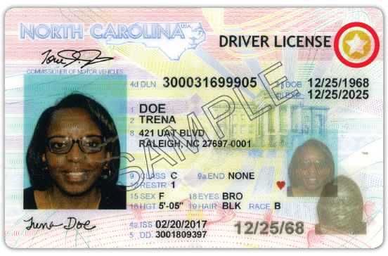
It’s time to get your gold star from the North Carolina DMV! Call 919-715-7000 to schedule an appointment to get your #NCREALID at your nearest #NCDMV driver license office. Gather your documents before your appointment. Get the complete list of required documents at NCREALID.gov.

SOCIAL MEDIA SAMPLES
Copy/paste any of the below
messages to use in your networks.

SHORT MESSAGES FOR TWITTER (140 CHARACTERS OR LESS)

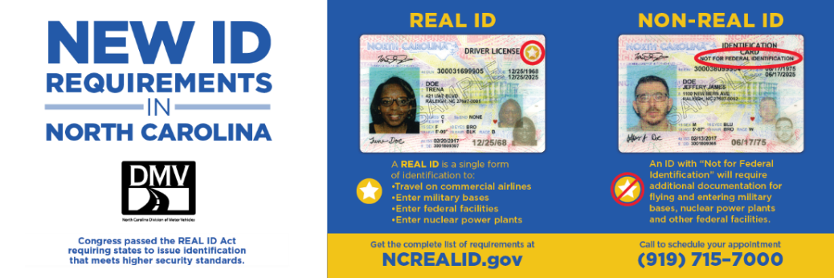
The #NCDMV now offers REAL ID, a new license and identification card that meets new federal guidelines. Learn more about #NCREALID at NCREALID.gov

The only difference between your current license & the #NCREALID is a gold star. No chip, no tracking. Learn more at NCREALID.gov. #myNCDMV

There are new ID requirements for traveling and accessing federal facilities in #NorthCarolina. Learn about the requirements and how you can meet them at NCREALID.gov.

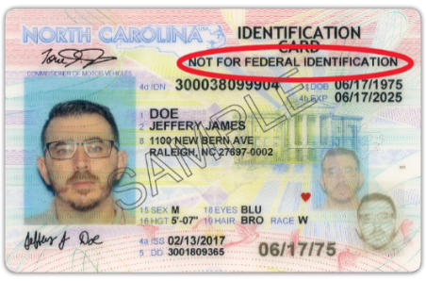

If you don’t get a #REALID, your next license/ID card will say “Not for Federal Identification”. Learn more at NCREALID.gov.

SOCIAL MEDIA SAMPLES
Copy/paste any of the below
messages to use in your networks.

Take a flight with #NCREALID, a single form of identification to board a plane. Get the details at NCREALID.gov

Earn your gold star when you get an #NCREALID! Find out how at NCREALID.gov.

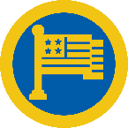

#NCREALID meets the federal identification requirements for TSA and federal facilities including military bases and nuclear power plants.

Want to get a gold star from the #NCDMV? Learn how at NCREALID.gov. #NCREALID

SOCIAL MEDIA SAMPLES
Copy/paste any of the below
messages to use in your networks.

GENERAL INFORMATION

- Before you renew your license, get the list of required documents for #NCREALID at NCREALID.gov.
- Renew your driver license with an #NCREALID six months before your card expires. Get the list of required documents from NCREALID.gov.
- Call 919-715-7000 to schedule an appointment for any of our driver license offices and apply for your #NCREALID. Get the details at NCREALID.gov
- Make the switch! Get an #NCREALID and fly anywhere, anytime! Learn how at NCREALID.gov.
- Get REAL and get your #NCREALID before the 2020 rush! Checkout what you need before you go at NCREALID.gov!
- There is no additional fee to renew your license/ID as a #NorthCarolina #REALID. Get the details at NCREALID.gov.
- Invest in the future…get your #NCREALID and save time at the airport. Get the list of required documents at NCREALID.gov
- Come aboard! It’s easy to fly with an #NCREALID. Learn how at NCREALID.gov. #TravelwithNCREALID
- Don’t let them swat your when you fly! Learn how to #travelwithNCREALID at NCREALID.gov.
- Obtaining an #NCREALID is like getting a license/ID for the 1st time. Visit the #NCDMV with your documents. Get the list at NCREALID.gov
- Without #NCREALID, you must show add’l ID to fly and enter federal facilities & military bases in 2020. Learn more at NCREALID.gov
- After you get your 1st #NCREALID at an #NCDMV office, you can get duplicates and renew your #REALID online at myNCDMV.gov. Call 919-715-7000 for an appointment.
- The #NCREALID is the same cost as the traditional #NCDMV license/ID card & arrives within 15 business days. Get more info at NCREALID.gov
- You can make an appointment to visit any #NC driver license office. Call 919-715-7000 when you’re ready to renew your license as a #NCREALID

SOCIAL MEDIA SAMPLES
Copy/paste any of the below
messages to use in your networks.

Not for Federal Identification

- NCDLs/IDs without a gold star will require add’l ID to fly & visit a military base or federal facility. Get more info at NCREALID.gov.
- An NCDL with “Not for Federal Identification” is a valid state-issued card with full driving privileges. #NCDMV #TheMoreYouKnow #NCREALID
- An #NC ID card with “Not for Federal Identification” is a state-issued card valid for identification purposes. #TheMoreYouKnow #NCREALID
- #DidYouKnow if you don’t get an #NCREALID your card will say “Not for Federal Identification”? Get the list of requirements at NCREALID.gov.
- Are you married? Remember to bring your marriage license & your other documents to get your #NCREALID. Get the document list at NCREALID.gov.

SECURITY

- Getting an #NCREALID for your child would establish their identity at an early age to prevent ID fraud. Get the requirements at NCREALID.gov
- The REAL ID Act is a response to 9/11. Learn more about #REALID on the @DHSgov website: https://www.dhs.gov/secure-drivers-licenses #myNCDMV
- Because it verifies your identity/address, the #NCREALID increases the security of your identification. Get the requirements at NCREALID.gov

DID YOU KNOW?

- #DYK the only difference between obtaining an #NCREALID & a standard card is having a 2nd proof of address? Get more info at NCREALID.gov
- #DidYouKnow you can apply for an #NCREALID at your next license renewal? Learn how to apply at NCREALID.gov
- #DidYouKnow you don’t have to wait to renew your license as an #NCREALID? You can get one now for $13. Find out how at NCREALID.gov
- #DidYouKnow traveling with #NCREALID will make it easier to get through security checkpoints at airports as the only ID needed to fly?#DidYouKnow getting an #NCREALID for minors is a great way to establish their identity? Get the list of required documents at NCREALID.gov.

